**Day 5 Lab Assignments**

**Design this layout by using Bootstrap:**

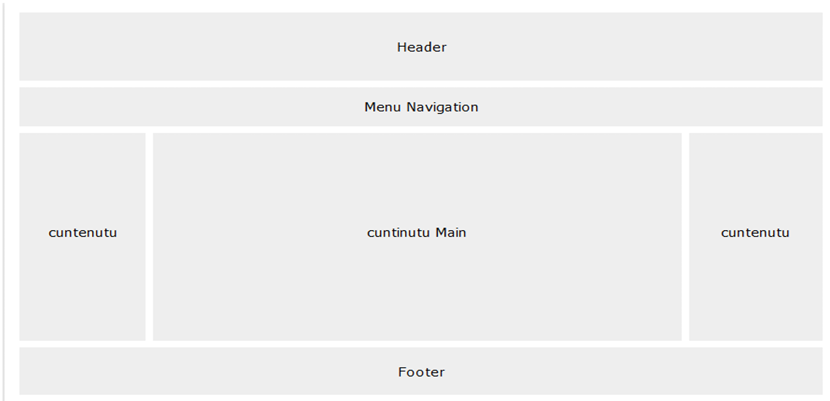

**Bonus Assignments:**

* Design the following sample page by using Bootstrap :

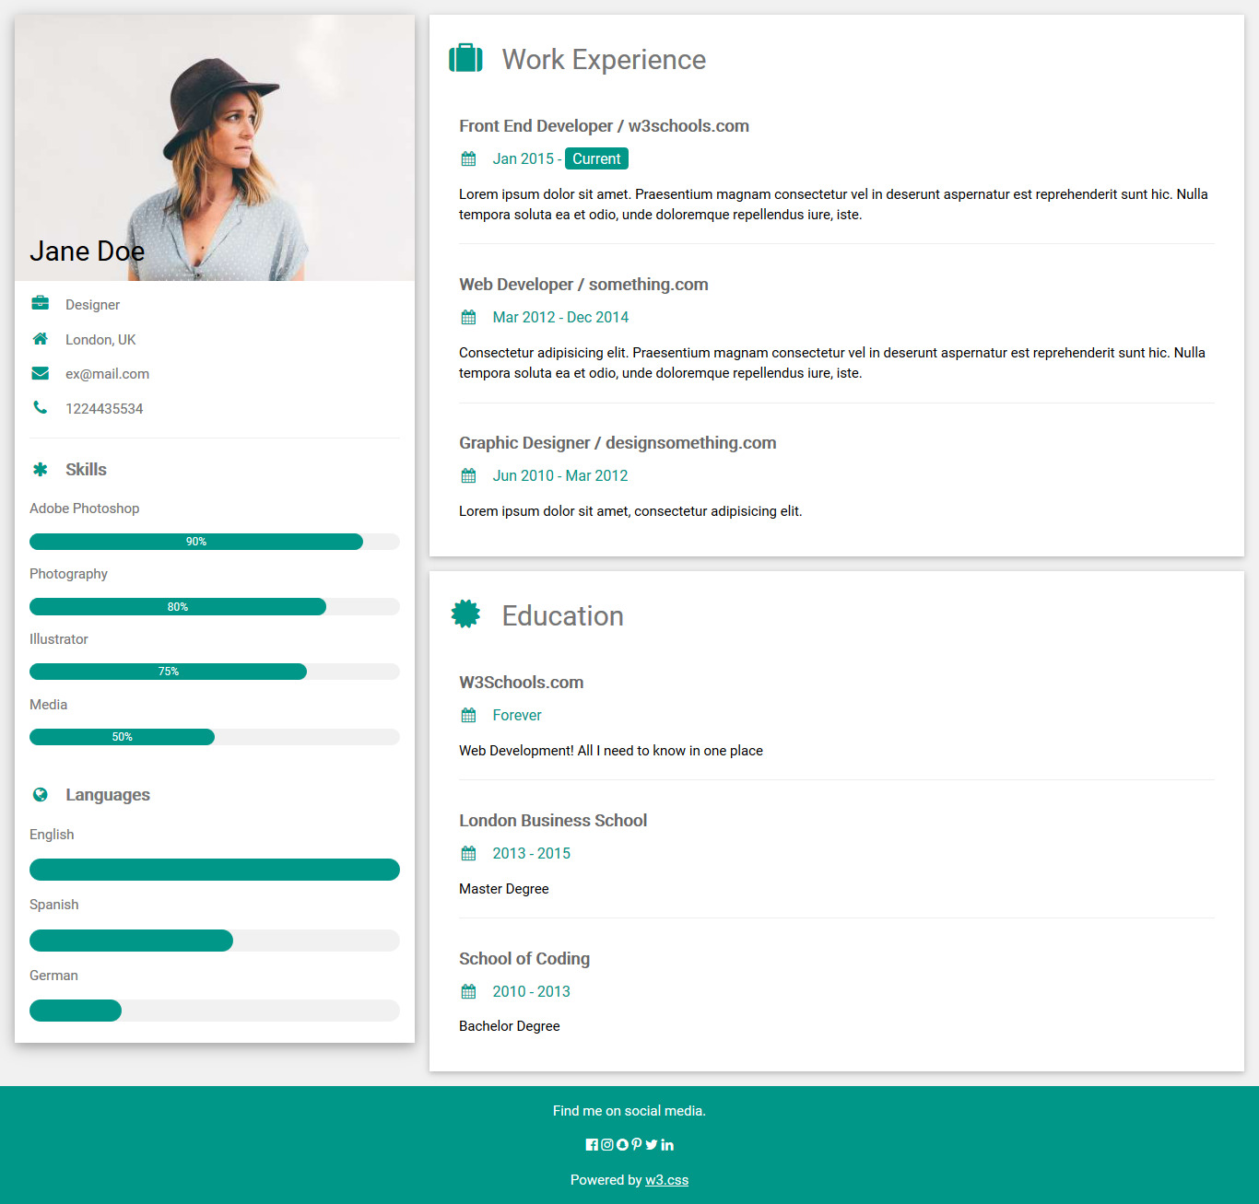

**<Thank>YOU </Thank>**